

Education vs Unemployment in South Africa: A Data Analysis

Module: NDTA 631 – Data Analysis and Visualization



**Institution:** Sol Plaatje University  
 **Group Members:** Boitelo Katleho Motsoto 202213685

Lebohang Rametsi 202300826

Nobuhle Thembalami Sibiya 202317888

Khensani Precious Maluleke 202306725

Vanessa Skosana 202226439

Zusiphe Xelelo 202301876

Mihlali Fana 202342128

**Introduction**   
South Africa has a special economic and social problem: unemployment is consistently high even with significant investments in education. A major research topic is brought up by this paradox: do lower unemployment rates result from higher educational enrollment?  
Two datasets from the World Bank Open Data platform school enrollment percentages and unemployment rates (by age and gender) were used in this project to examine this subject. We sought to clean, filter, and analyze the data in a way that reveals long-term trends by fusing Excel features (conditional formatting and visualization) with programming tools (Python, Pandas, NumPy, SQLite, and Matplotlib).   
  
The results shed light on the relationship between education and work while also highlighting more serious structural issues with South Africa's labor system.

**Dataset Details**

The data for this analysis was sourced from **World Bank Open Data**. We selected two datasets:

1. **School Enrollment (% of school-age population)** – This dataset captures how many students are enrolled compared to the official school-age population.
2. **Unemployment Data** – Youth unemployment, as well as breakdowns by gender (Female, Male, and Total).

**Dataset overview:**

* Country: South Africa (filtered from global datasets).
* Years covered: ~1990–2022.
* Variables:
  + Female_Unemployment (%)
  + Male_Unemployment (%)
  + Total_Unemployment (%)
  + Education_Enrollment (%)

Both datasets were merged on **Country** and **Year** (TIME_PERIOD). This created a combined dataset for analysis.

<https://data360.worldbank.org/en/indicator/WB_HCP_UNE_2EAP_MF_Y>

<https://data360.worldbank.org/en/indicator/WB_WDI_SE_SEC_ENRR>

merged dataset - <https://solplaatjeuniversity-my.sharepoint.com/:x:/g/personal/202213685_spu_ac_za/EafELdJ74RJMrcYJBPkZf0EBilyQTA2IS8hkg2XO_9e1gQ?e=oDQw9Z&nav=MTVfe0Y0MEE0REQxLTVEMzUtNDMzMi1BODlELThGRDM4Njg3MUJDNH0>

**Data Preparation**

Raw datasets often contain inconsistencies such as missing values, extra countries, or misaligned labels. The following cleaning steps were performed in Python (Jupyter Notebook):

1. **Filtering:** Only South Africa was retained, since the study focused exclusively on this country.
2. **Column renaming:** Indicators such as *“Youth Unemployment, Female (% of female labor force ages 15–24)”* were shortened to *Female_Unemployment*.
3. **Missing values:** Rows with no unemployment or enrollment data were dropped.
4. **Merging:** The two datasets were joined on **Year**.

After cleaning, the dataset contained consistent yearly records for South Africa, ready for numerical and visual analysis.

**Numerical Analysis**

Using **Pandas** and **NumPy**, we calculated several metrics:

* **Averages:**
  + Average Female Unemployment: ~44.34%
  + Average Male Unemployment: ~36.79%
  + Average Education_Enrollment: ~92%
  + Average Total:~40.1%
* **Gender Gap:**
  + Female unemployment was consistently higher than male unemployment by **8–10 percentage points**.
  + This gap persisted across decades, highlighting ongoing gender disparities in the labor market.
* **Trends:**
  + Education enrollment steadily increased, especially after the early 2000s.
  + Unemployment remained high, showing little correlation with education.

**Data Visualisation**

Several charts were created using **Matplotlib** and **Seaborn** to illustrate patterns:

1. **Line Chart – Unemployment over Year**
   * Shows unemployment rising after 2010, peaking close to 50%.
2. **Line Chart – Education Enrollment over Time**
   * Steady improvement in enrollment, surpassing 100% in recent years.
3. **Comparison Plot (Enrollment vs Unemployment)**
   * Demonstrates that higher enrollment does not correlate with lower unemployment.
4. **Gender Trends**
   * Female unemployment consistently above male unemployment.

These visualisations make the trends easier to understand than raw numbers alone.

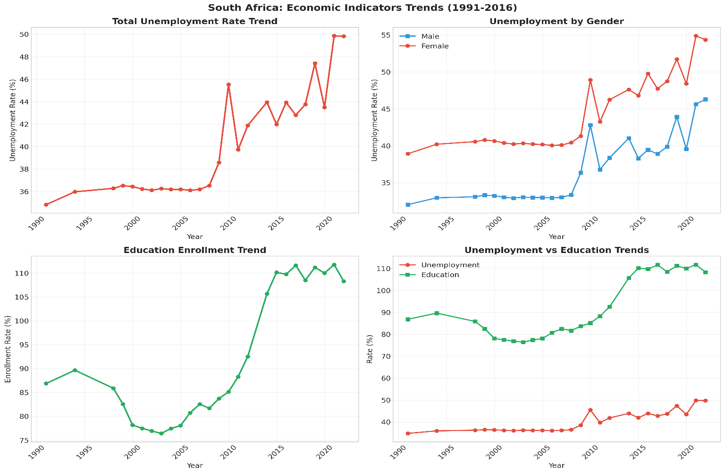

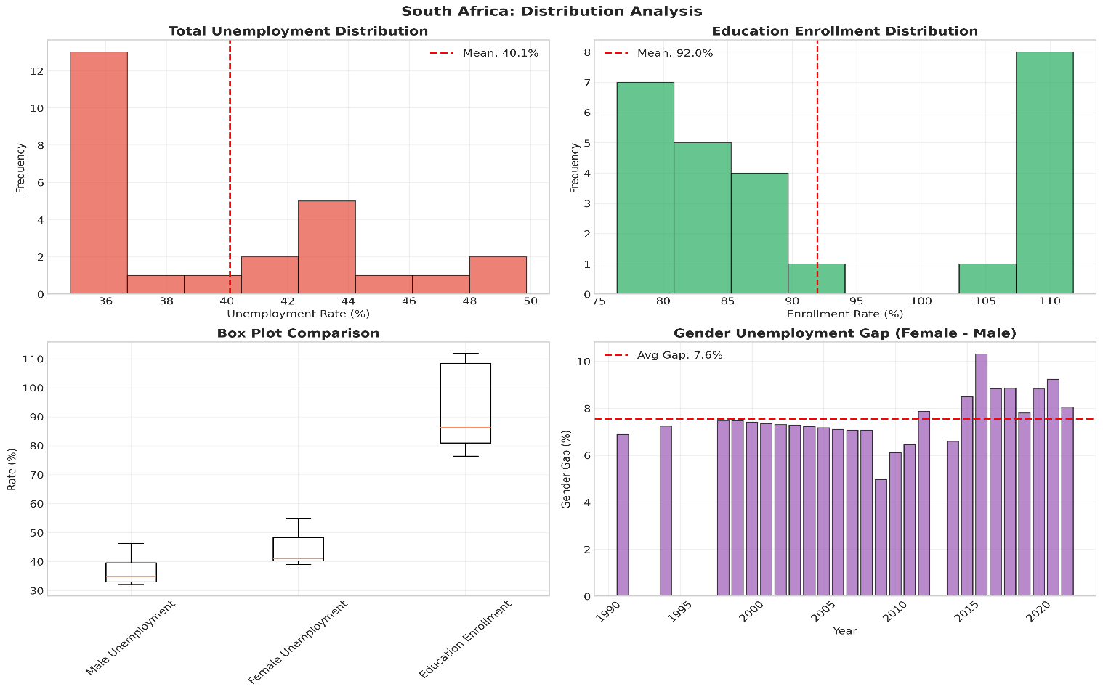

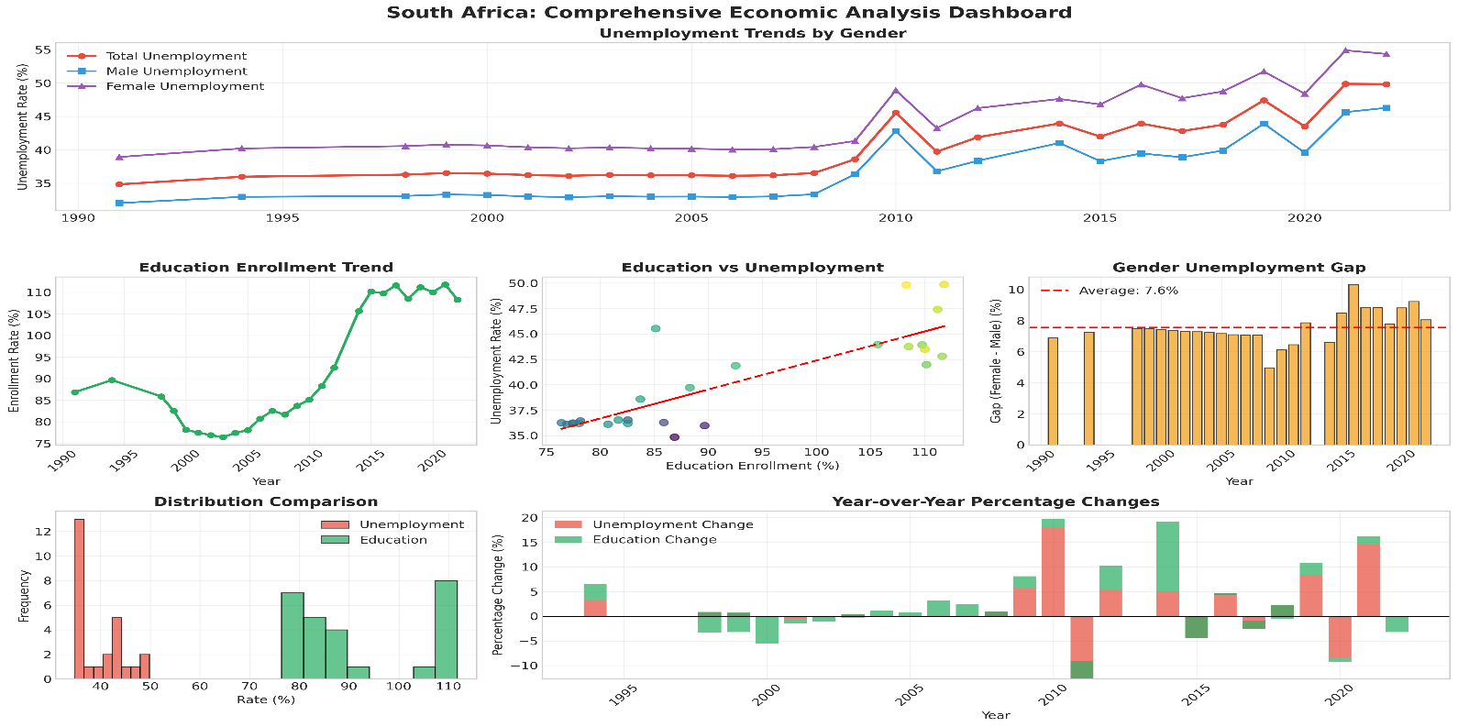

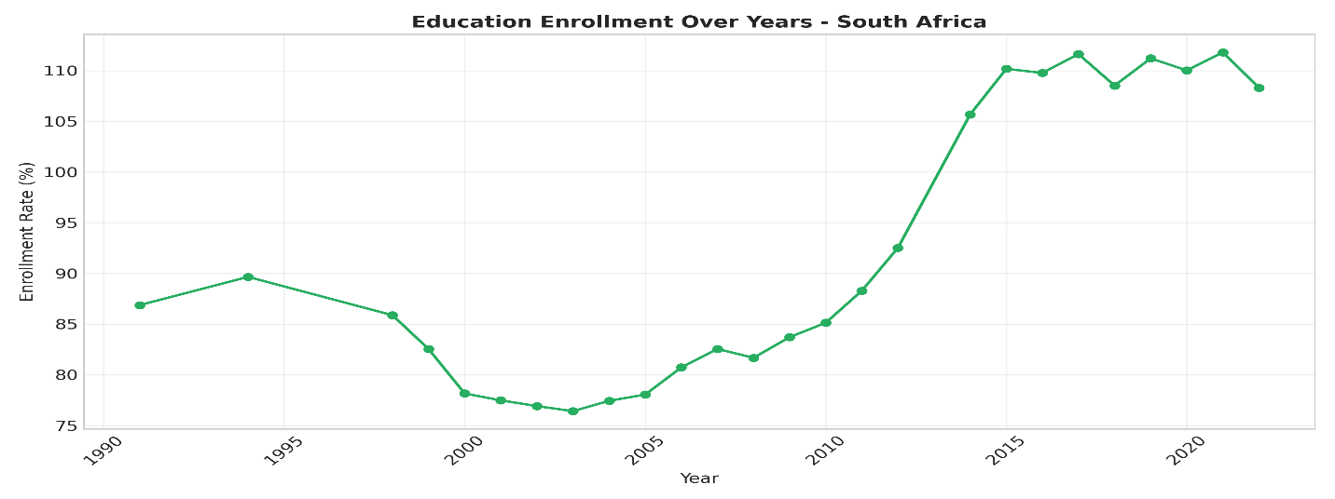

**Database Integration**

An **SQLite database** was created to manage the cleaned dataset. Three tables were included:

* school_enrollment
* youth_unemployment
* education_vs_youth_jobs (merged table)

We also tested **update and delete operations**, ensuring that records could be modified safely. Finally, the database was reloaded into Pandas to continue analysis in Python.

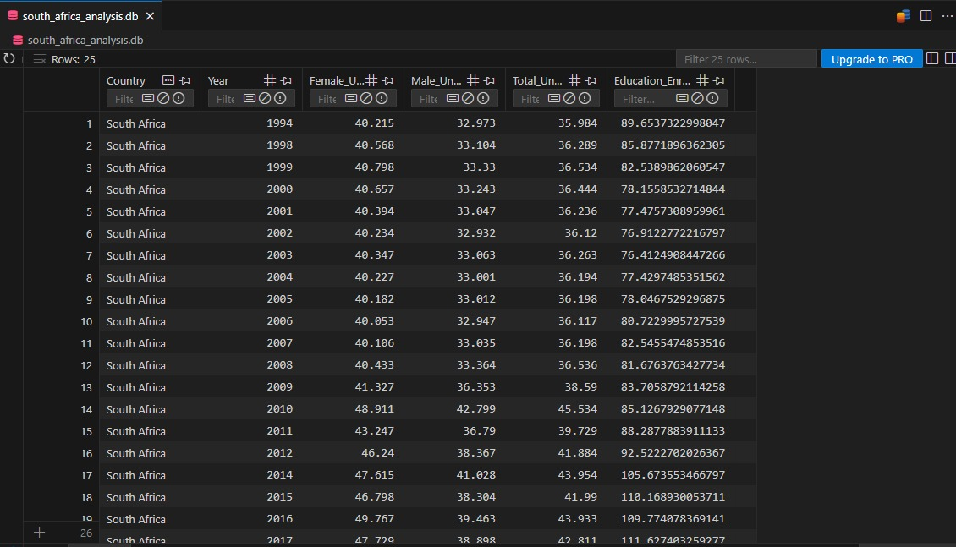

**Python & Excel Data Analysis**

Beyond Python, Excel was used to apply **conditional formatting** for further insights:

* **High Unemployment:** Any year with Total_Unemployment > 40% was highlighted.
* **Low Enrollment:** Enrollment below 80% was highlighted in yellow.
* **Data Bars:** Applied to unemployment to visualize severity.

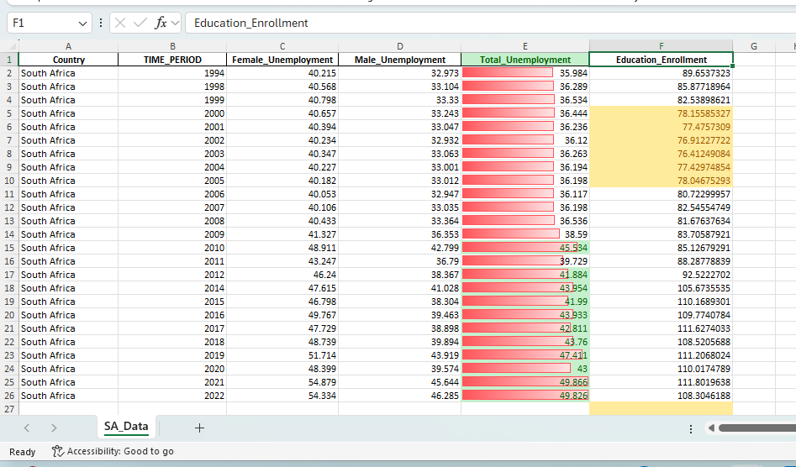

**Findings from Excel:**

According to the Excel conditional formatting, South Africa's unemployment rate has been extremely high for a long time ,it frequently exceeds the 40% crisis level and even approaches 50% after 2010. Enrollment in education also increased gradually, from less than 80% in the late 1990s to more than 100% in the most recent years. Better access to education alone won't address the unemployment situation, though, as the rise in education hasn't resulted in lower unemployment, which suggests deeper economic problems.

**Conclusion**

Three main conclusions emerged from the analysis: 1. High jobless Persists: For many years, particularly after 2010, South Africa's jobless rate has continuously remained above 40%. 2. Education Enrollment Improved: In recent years, enrollment has risen significantly and surpassed 100%. 3. No Direct Link: Unemployment has not decreased in spite of increased access to education. This suggests that there are systemic problems with the economy, such a lack of jobs, a mismatch in skills, or poor job creation. The necessity for focused interventions is further supported by the gender analysis, which also showed that women experience greater unemployment rates than males.

**References**

-World Bank Open Data: <https://data.worldbank.org>

1. Lam, D., Leibbrandt, M. and Mlatsheni, C., 2009. Education and youth unemployment in South Africa. In Labor markets and economic development (pp. 90-109). Routledge. <https://www.taylorfrancis.com/chapters/edit/10.4324/9780203881699-6/education-youth-unemployment-south-africa-david-lam-murray-leibbrandt-cecil-mlatsheni>

2. Reuters, 2025. South Africa’s unemployment rate rises to 32.9% in first quarter 2025. [online] Available at: <https://www.reuters.com/world/africa/south-africas-unemployment-rate-rises-329-first-quarter-2025-05-13>

1. Statistics South Africa (Stats SA), 2025. Quarterly Labour Force Survey, Q2 2025: Media Release. [online] Available at: <https://www.statssa.gov.za/publications/P0211/Media%20Release%20QLFS%20Q2%202025.pdf>
2. Statistics South Africa (Stats SA), 2021. Labour Market Dynamics and Education Report. [online] Available at: <https://www.statssa.gov.za/publications/Report-03-01-81/PresentationUpdatedFinal.pdf>